
Monday, June 22nd
10:30am Bingo in the Activity Room
1:00pm PBS The American Revolution in the
Library
2:00pm Chair Exercise w/ Nate in the Activity
Room
3:00pm Fast Eddie in the Library
3:45pm Diane’s Bible Study in the Activity
Room
Tuesday, June 23rd
Happy Birthday Mary H!
11:00am Group Crossword in the Activity Room
12:30pm VMR $1.50 store open in Library
1:00pm Exercise Sampler w/ Kelly in the
Activity Room
1:30pm PBS The American Revolution in the
Library
3:30pm American True or False in the Activity
Room
Wednesday, June 24th
10:30-2:00pm Spelling Bee at the Hartland
Senior Center. Please signup to be
apart of the cheering group for the
spellers.
10:30am Music Therapy w/ Kelsey in the Activity
Room 1:00pm PBS The American Revolution in the
Library
2:00pm Honest Talk About Dementia w/ DJ in
the Upper Conference Room
2:00pm Chair Exercise w/ Nate in the Activity
Room
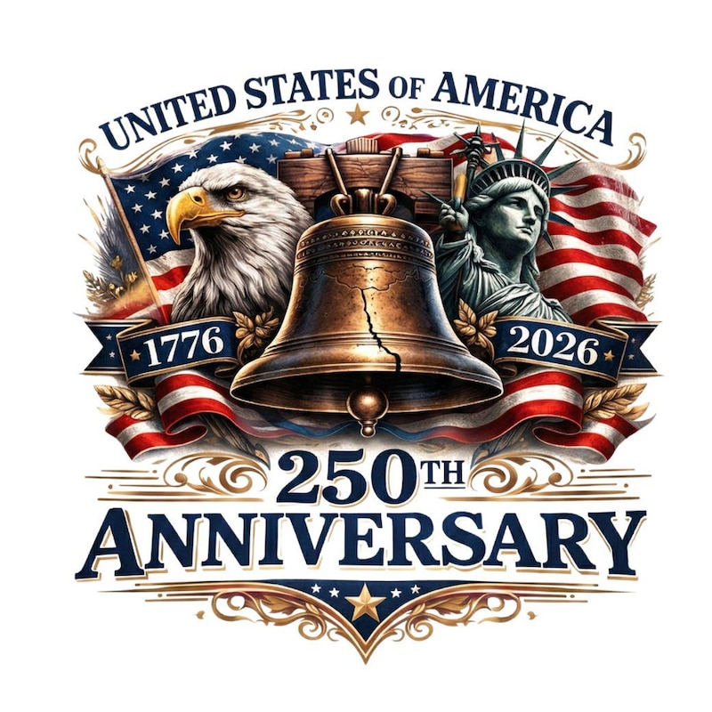


Thursday, June 25th
10:30am Joyful Movement with Karen in the
Upper Conference Room
11:00am PBS The American Revolution in the
Library
3-7pm USA 250th Anniversary Celebration. SEE FLYER ATTACHED FOR DETAILS

Special thanks to Details Event Design for the
sponsorship regarding this event.
Friday, June 26th
9:45am Shopping: Meijer
11:00am Exercise w/ Renee in the Activity Room
1:00pm PBS The American Revolution in the
Library
3:00pm Happy Social Hour in the Activity Room
Saturday, June 27th
10:30am Bingo in the Activity Room
1:30pm Euchre w/ Ray in the Café
2:30pm Afternoon Movie: “Washington” in the
Library
3:30pm Coloring and Conversation in the
Activity Room
Sunday, June 28th
Happy Birthday
Peter F!
10:00am Worship with Revival Global Methodist
Church in library
1:00pm Catholic Communion Service in the
Activity Room
6:00pm After dinner cards, guided by the
residents in the Activity Room

10:30am Worship Livestream with Revive Global
Methodist Church in the library
1:00pm Catholic Communion Service in the
activities room. All are welcome!
2:30pm
6:00pm After dinner cards of choice in activities



Weekly Highlights

🌟 Weekly Activities Highlight 🌟

🧠 Tuesday, June 23rd
3:30 PM – True or False Trivia
📍 Activity Room
Come test your knowledge and have some fun!

💬 Wednesday, June 24th
2:00 PM – “Honest Talk About Dementia”
📍 Upper Conference Room
An open and informative discussion—everyone welcome.

🎉 Thursday, June 25th
3:00 – 7:00 PM – USA 250th Anniversary Celebration
📍 Outdoor Event
Join us for a special celebration with fun, community, and patriotic spirit!

- Right” game. Guess prices of many different ideas. Come for a laugh with Brian and Renee
- Thursday, September 2nd at 1:30pm in the Activities Room come to see what Jasmine from Motivated and Moving has instore for us. She will be explaining her exhilarating program of various activities. This will take place in each alcove in the building held on Mondays through the month of September. If you participate in each program, you will be entered into a drawing for a health and wellness package!
- Saturday, September 4th at 1:30pm in the Activities Room come to “Get Craftin’ Hour” with Renee to create Melted Crayon Jewelry.

Nurse Andrea Cherry-Watson acherry-watson@vmretirement.com
Care Coordinator Lynn Balaka lbalaka@vmretirement.com

